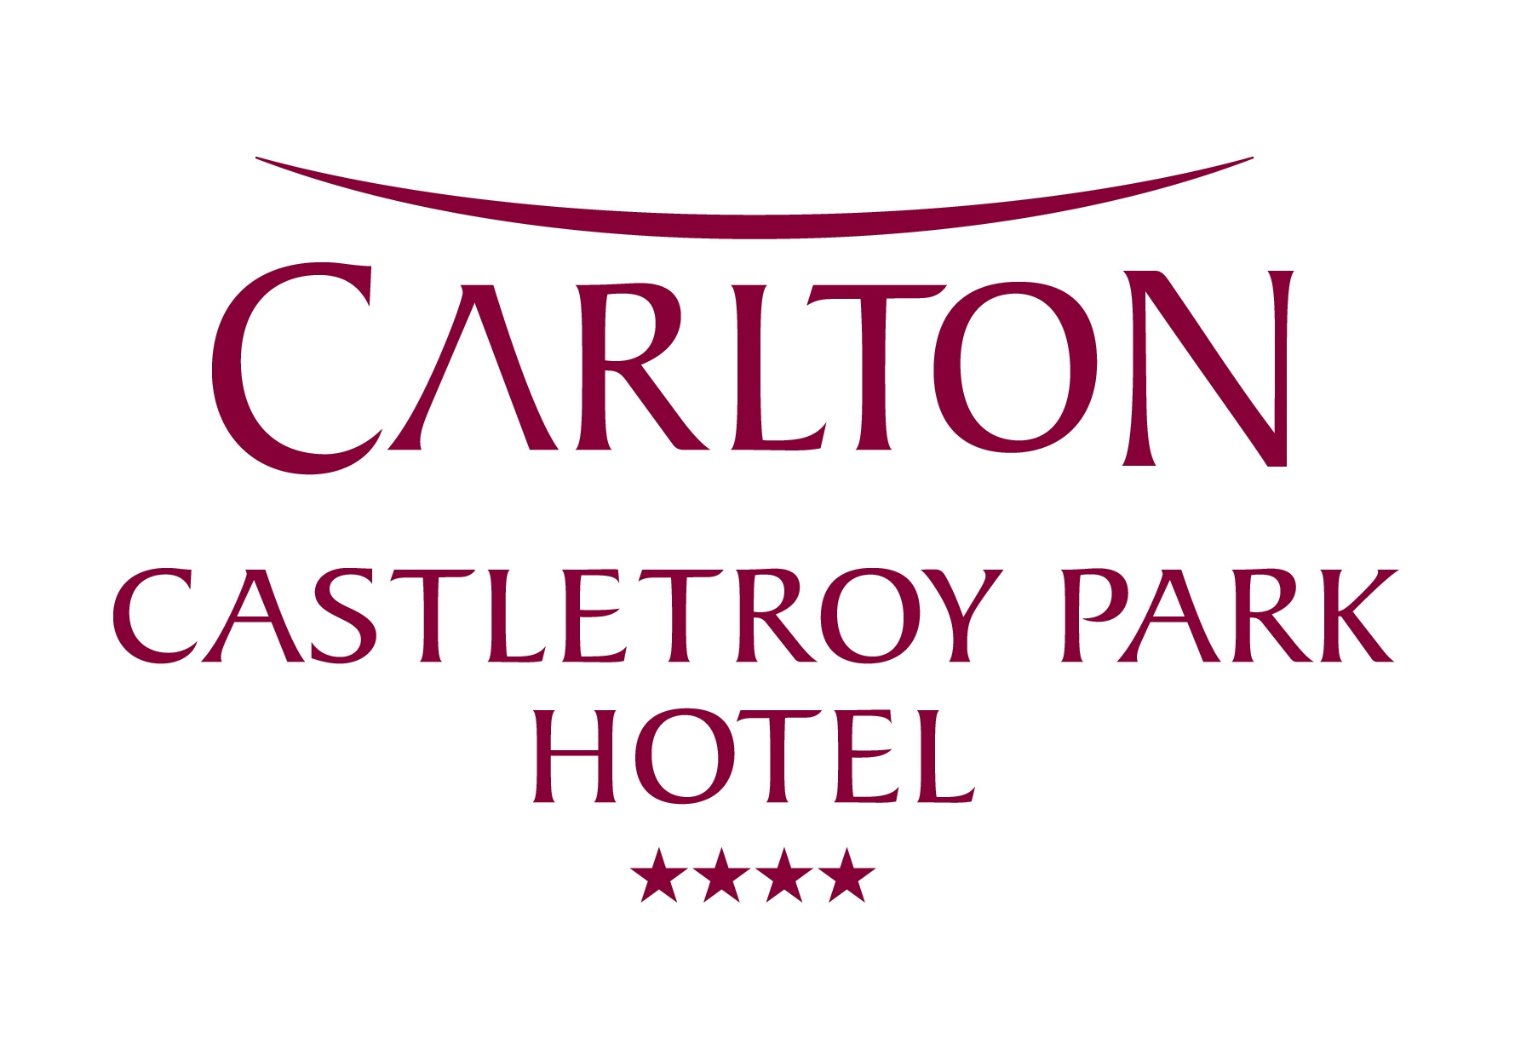

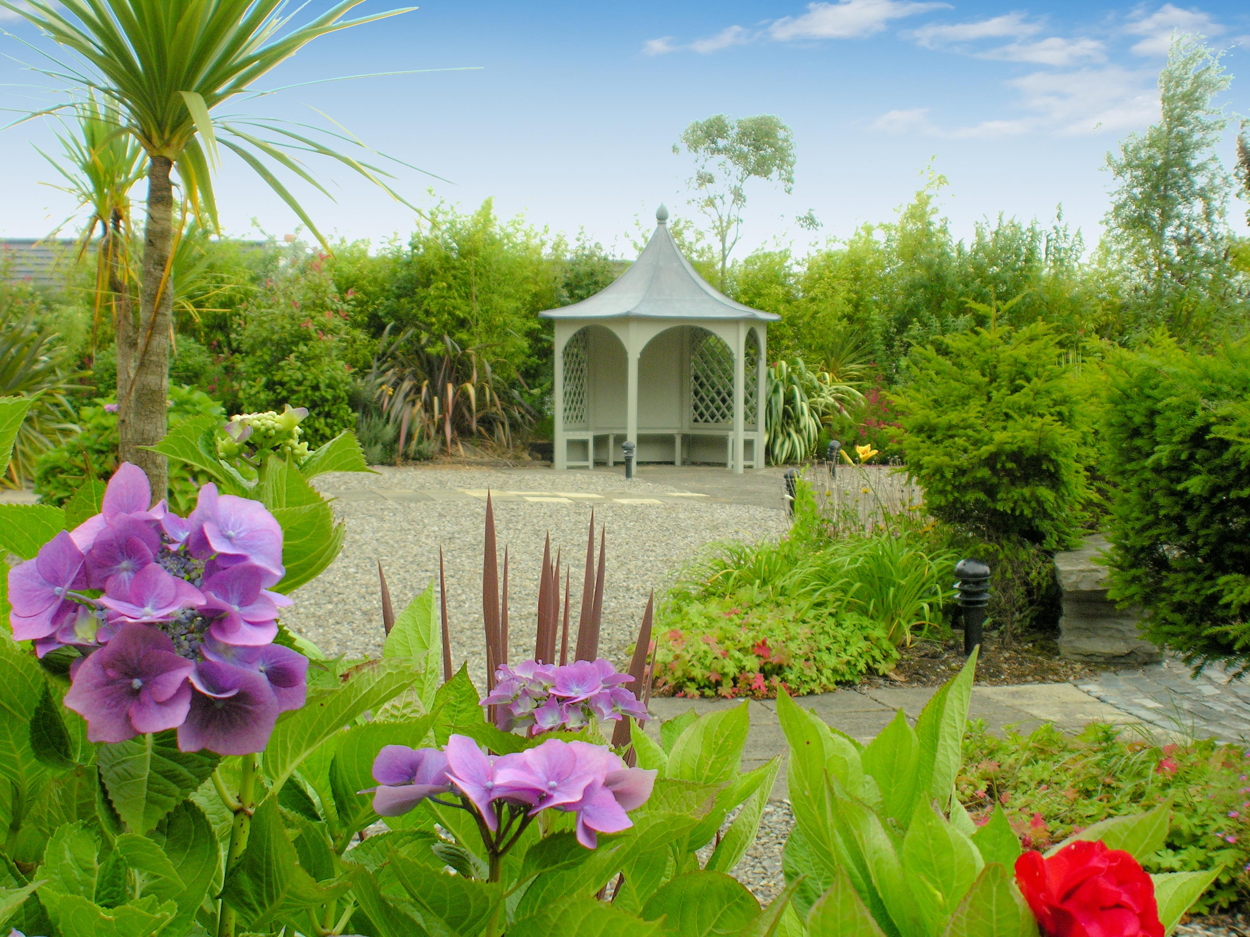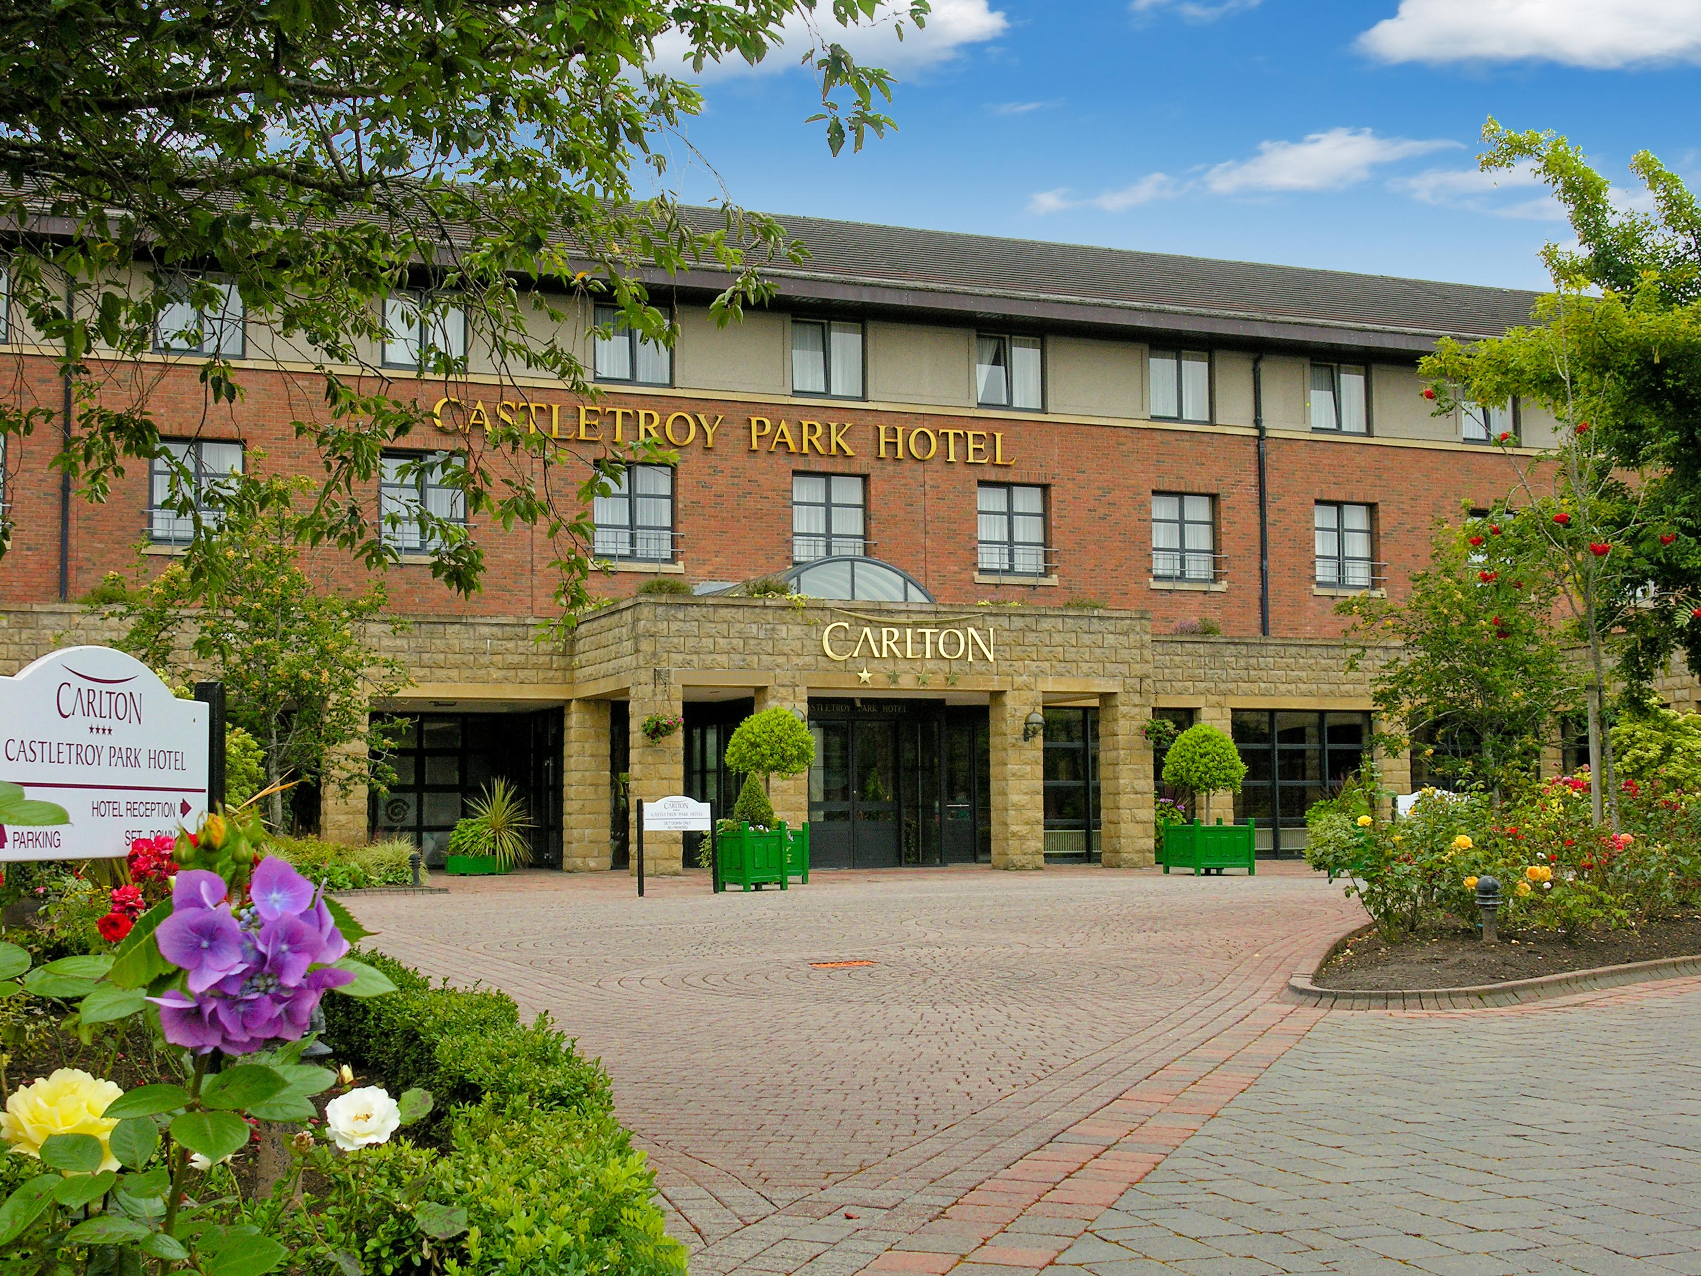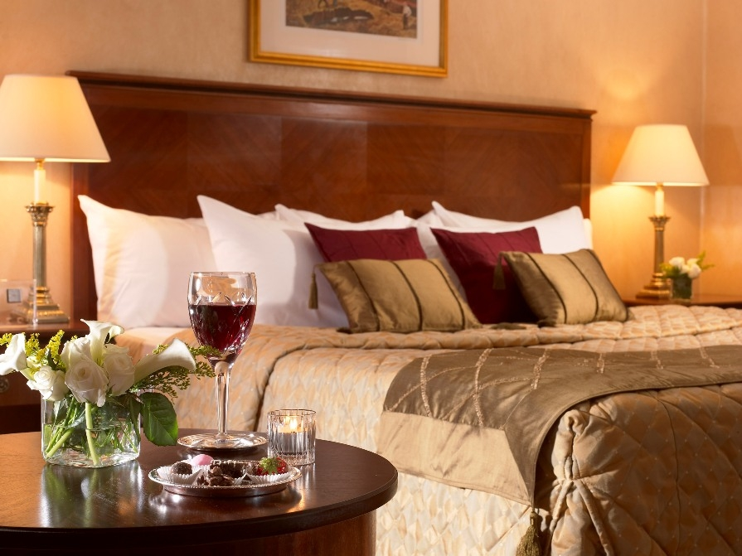

The Carlton Castletroy Park Hotel is regarded as one of the leading Hotels in Limerick.
(Closest walking distance hotel to the University of Limerick)
The hotel’s leisure centre complete with newly installed fitness equipment, sauna, steam room, Jacuzzi and Limericks only indoor 20 meter pool is ideal for a vigorous work out or a relaxing swim. Relax in our unique C Salon, which offers you a variety of beauty and body treatments using the internationally renowned Dr. Murad skin care products
Carlton Castletroy Park Hotel
WCRE Special Offer 17th – 20th of October 2011
Only €79 for Single Occupancy or €89 for 2 persons sharing
Per night Bed & Breakfast
Special Dinner Supplement of €20.00 per person per night
If you want to upgrade to our Dinner Package
Please quote WCRE Conference when booking
For Reservations please call
Carlton Castletroy Park Hotel
Dublin Road
Limerick
T: + 353 (0) 61 335566
F: +353 (0) 61 331117
E: reservations.castletroy@carlton.ie
W: www.carlton.ie/castletroy

